**GLOBAL SUPERSTORE MANAGEMENT**

**Milestone 3**

**Group-16**

**Laawanyaa Sai Thota**

**Udhay Chityala**

**Submission Date: 11/22/2023**

**Query 1) Find all delivery orders from orders table**

**Analytical Purpose: Manager wanted to look at the delivery orders to view their payment status, store and customerid**

SELECT *

FROM orders

WHERE Order_Category = 'delivery';

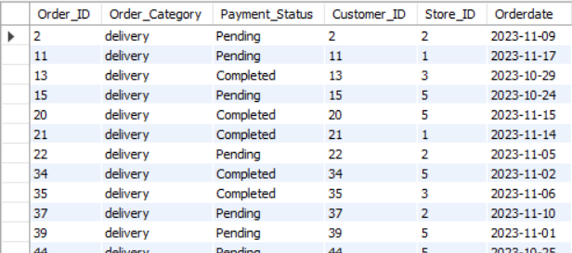

**Query 2) Find the number of orders in each store**

**Analytical Purpose: Identifying the orders per store to analyze the store performance and plan on any marketing campaigns to promote sales in low performing stores**

SELECT Store_ID,

Count(*) AS No_of_orders

FROM orders

GROUP BY Store_ID;

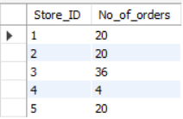

**Query 3) Find customers who made purchases using Credit Card**

**Analytical Purpose: Identifying the customers who made purchases with credit card to approve their transaction after adding tip (if any).**

SELECT DISTINCT C.Customer_ID, C.First_Name, C.Last_Name

FROM Customer C

LEFT OUTER JOIN Orders O ON C.Customer_ID = O.Customer_ID

LEFT OUTER JOIN Payment P ON O.Order_ID = P.Order_ID

WHERE Mode_of_Payment = "Credit card"

ORDER BY Customer_ID;

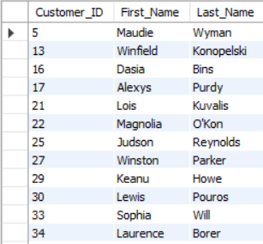

**Query 4) Find the total amount spent by each customer in descending order of their spending**

**Analytical Purpose: Identifying and rewarding the top 3-5 high-value customers with personalized gift cards in celebration of Thanksgiving**

SELECT C.Customer_ID, C.First_Name, C.Last_Name, SUM(P.Amount) AS Total_spend_$

FROM orders O

LEFT OUTER JOIN Payment P ON O.Order_ID = P.Order_ID

LEFT OUTER JOIN customer C ON O.Customer_ID = C.Customer_ID

GROUP BY C.Customer_ID,C.First_Name,C.Last_Name

ORDER BY Total_spend_$ DESC;

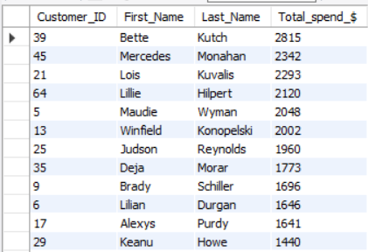

**Query 5) Find the store with highest revenue**

**Analytical Purpose:** **Determining the top-performing store based on revenue to award the coveted 'Super Store!!' recognition as part of the company's monthly awards to inspire and motivate the team.**

SELECT S.Store_ID, SUM(P.Amount) AS Total_revenue_$

FROM orders O

LEFT OUTER JOIN Payment P ON O.Order_ID = P.Order_ID

LEFT OUTER JOIN store S ON O.Store_ID = S.Store_ID

GROUP BY S.Store_ID

HAVING Total_revenue_$ = (SELECT MAX(Total_revenue_$)

FROM (SELECT S.Store_ID, SUM(P.Amount) AS Total_revenue_$

FROM orders O

LEFT OUTER JOIN Payment P ON O.Order_ID = P.Order_ID

LEFT OUTER JOIN store S ON O.Store_ID = S.Store_ID

GROUP BY S.Store_ID ) AS Store_rev);



**Query 6) Find all customers with atleast 2 orders**

**Analytical Purpose: Identifying the repeating customers to**

SELECT C.Customer_ID, C.First_Name, C.Last_Name

FROM Customer C

WHERE EXISTS (SELECT O.customer_ID,count(*) as no_of_orders

FROM Orders O

WHERE C.Customer_ID = O.Customer_ID

GROUP BY O.customer_ID

HAVING no_of_orders>=2);

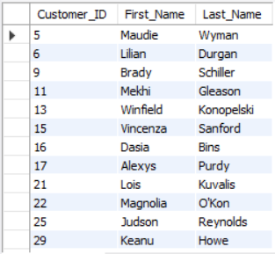

**Query 7) Find distribution of revenue by payment mode**

**Analytical Purpose: Identifying the share of each payment method so that we can contact a credit/debit card vendor for special offers for using their credit/debit card which boosts the sales**

SELECT Mode_Of_Payment,

SUM(amount) AS Revenue,

ROUND(100*SUM(amount)/(SELECT SUM(amount) FROM Payment),2)

AS 'Revenue_Share(%)'

FROM Payment

GROUP BY Mode_Of_Payment

ORDER BY Revenue

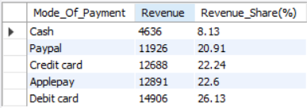

**Query 8) Find Top 5 Customers with Highest average order value (AOV) and their Lite time Revenue (LTR)**

**Analytical Purpose: To find the top 5 customers based on their average order value and understand their lifetime revenue and number of orders based on which we can give them personalized rewards/loyalty points.**

SELECT Customer_ID,

First_Name,

Last_Name,

ROUND(AOV,2) AS 'AOV($)',

Total_rev AS ‘LTR($)’,

No_of_orders

FROM (SELECT C.Customer_ID, C.First_Name, C.Last_Name, AVG(P.amount) AS AOV, COUNT(p.amount) AS No_of_orders, SUM(P.amount) AS Total_rev,

RANK() OVER (ORDER BY AVG(P.amount) DESC,SUM(P.amount) DESC) AS Cust_Rank

FROM Customer C

LEFT OUTER JOIN Orders O ON C.Customer_ID = O.Customer_ID

LEFT OUTER JOIN Payment P ON O.Order_ID = P.Order_ID

GROUP BY C.Customer_ID, C.First_Name, C.Last_Name

) RankedCustomers

WHERE Cust_Rank <= 5;

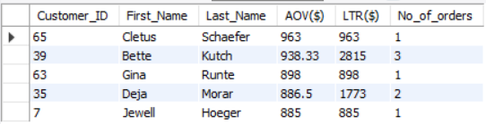

**Query 9) Find Top 2 Payment methods in each store by sales ($)**

**Analytical Purpose: To find the sales($) by payment method based on which our manager can take a call on whether to purchase an additional cash counting machine (if cash has major share in the sales($))**

SELECT Store_ID, Mode_of_Payment, Cat_rev AS 'Category_rev($)',

(SELECT SUM(amount)

FROM Orders O

LEFT OUTER JOIN Payment P on O.Order_ID = P.Order_ID

WHERE O.Store_ID = p1.store_ID) AS 'Store_rev($)',

ROUND(100*Cat_rev/(SELECT SUM(amount)

FROM Orders O

LEFT OUTER JOIN Payment P on O.Order_ID = P.Order_ID

WHERE O.Store_ID = p1.store_ID) ,2) AS 'Rev_Share_in_store(%)'

FROM (SELECT O.Store_ID,

P.Mode_of_Payment ,

SUM(P.amount) AS Cat_rev,

RANK() OVER (PARTITION BY O.Store_ID ORDER BY SUM(P.amount) DESC) AS Payment_Rank

FROM Orders O

LEFT OUTER JOIN Payment P ON O.Order_ID = P.Order_ID

GROUP BY O.Store_ID,p.Mode_of_Payment) AS P1

WHERE Payment_Rank<=2

ORDER BY Store_ID,Cat_rev DESC;

